DEVOPS ASSIGNMENT

|  |  |
| --- | --- |
| NAME | KAILASH S |
| DATE | 09-01-24 |
| ASS.NO | 2 |
| TOPIC | AZURE REPOS |

CREATINHG A REPO IN AZURE DEVOPS:

Login and create a organization in azure.

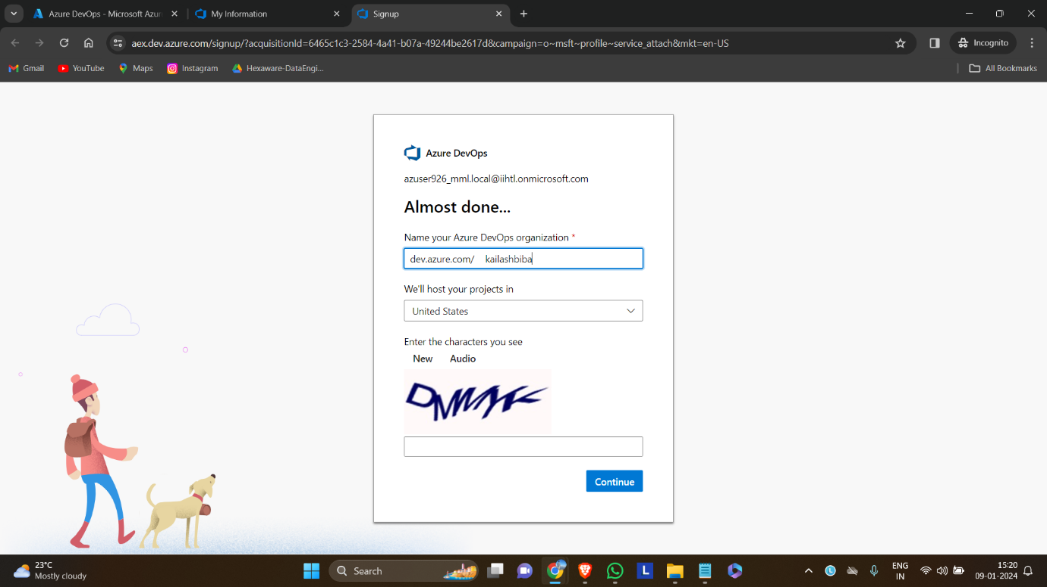

Create a new project

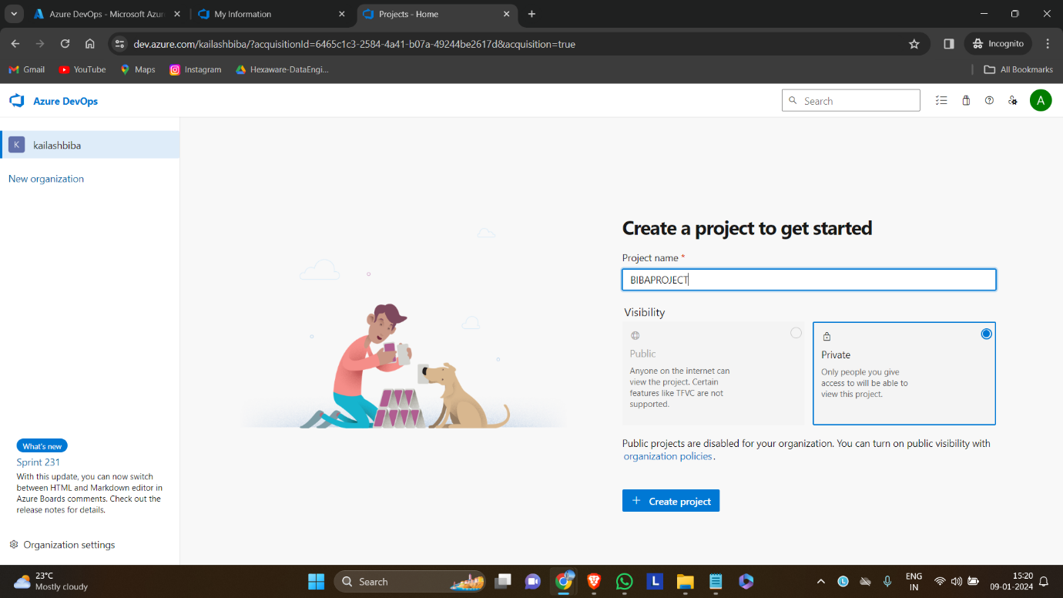

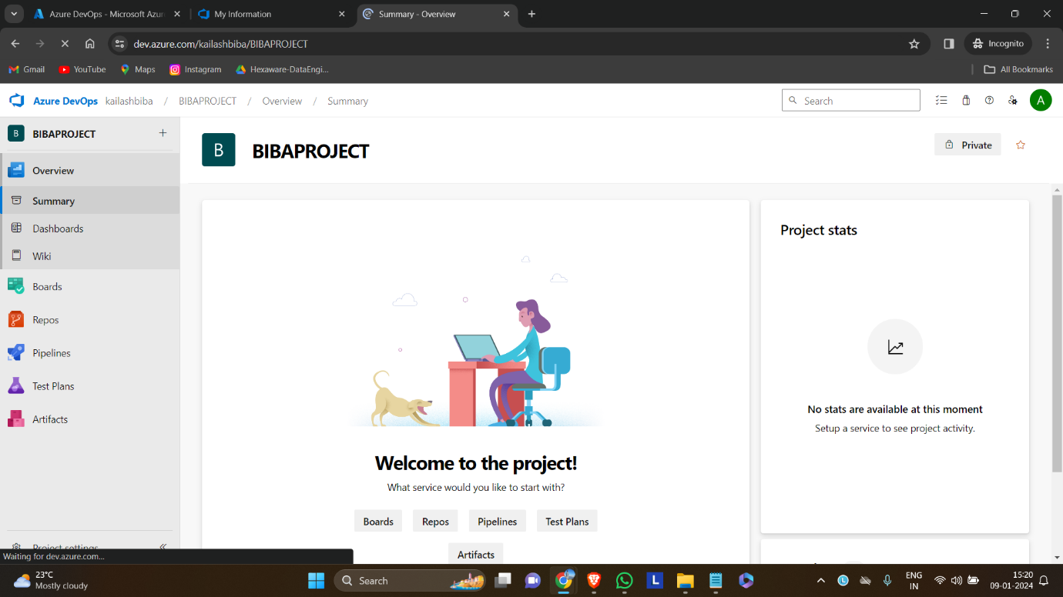

Creating an epic in azure boards

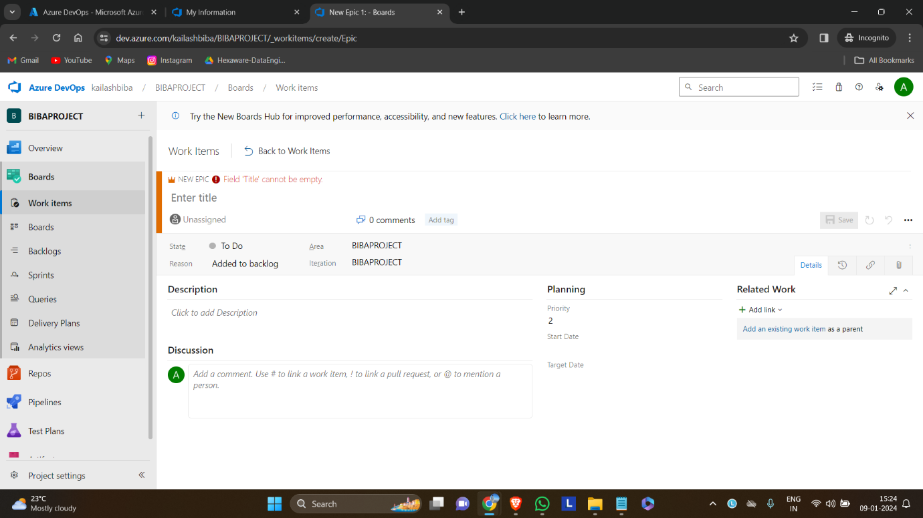

Creating a new azure repository.

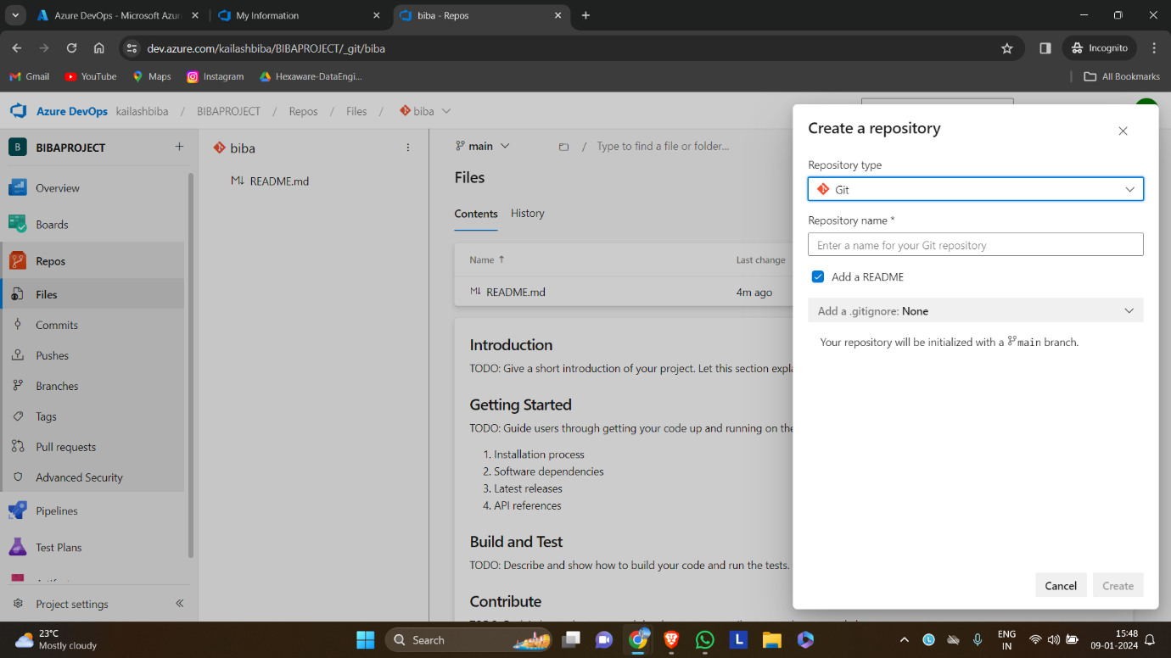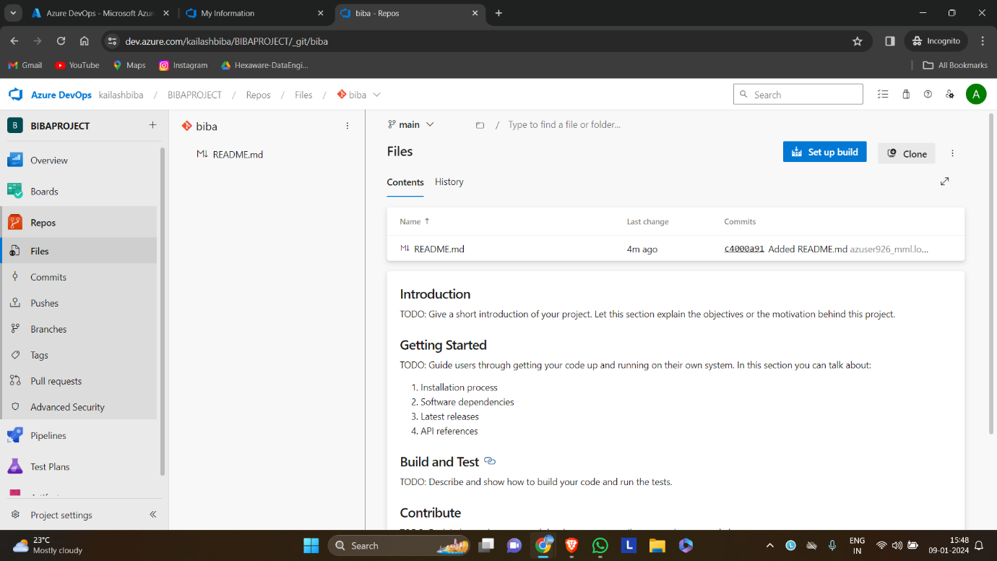

Cloning the repository to local directory

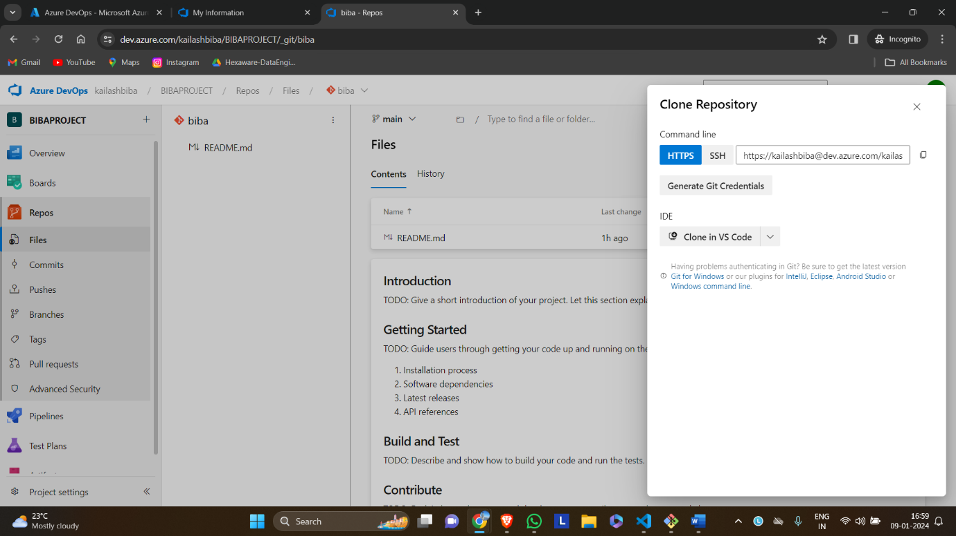

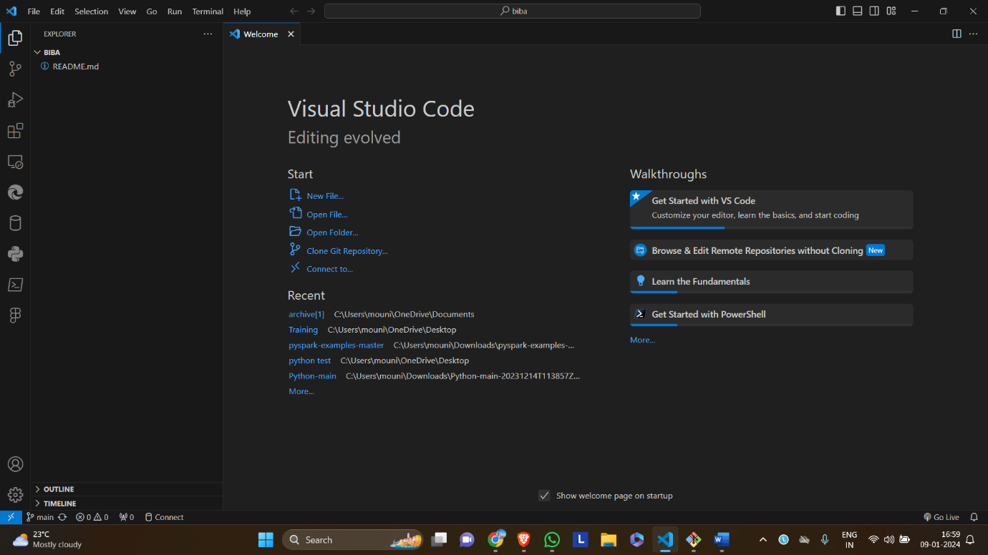

Committing the changes to the repository using git bash

Open git bash and enter the commands (on repository location).

1. git add new.py
2. git commit -a -m “my first commit”
3. git push

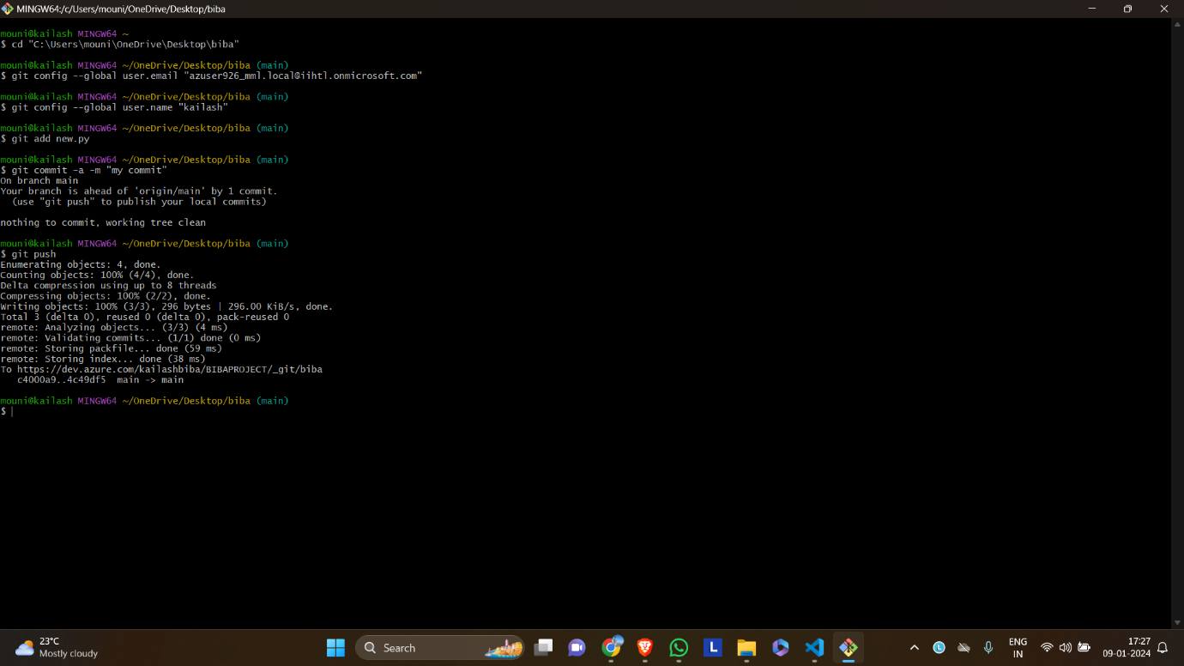

Can check the commits in history.

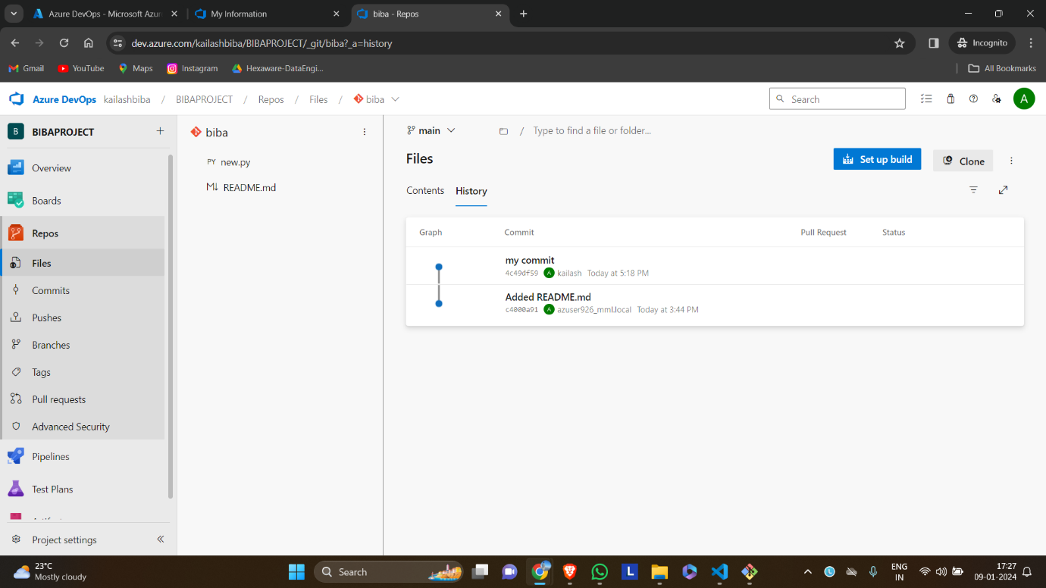

Viewing the commiited file

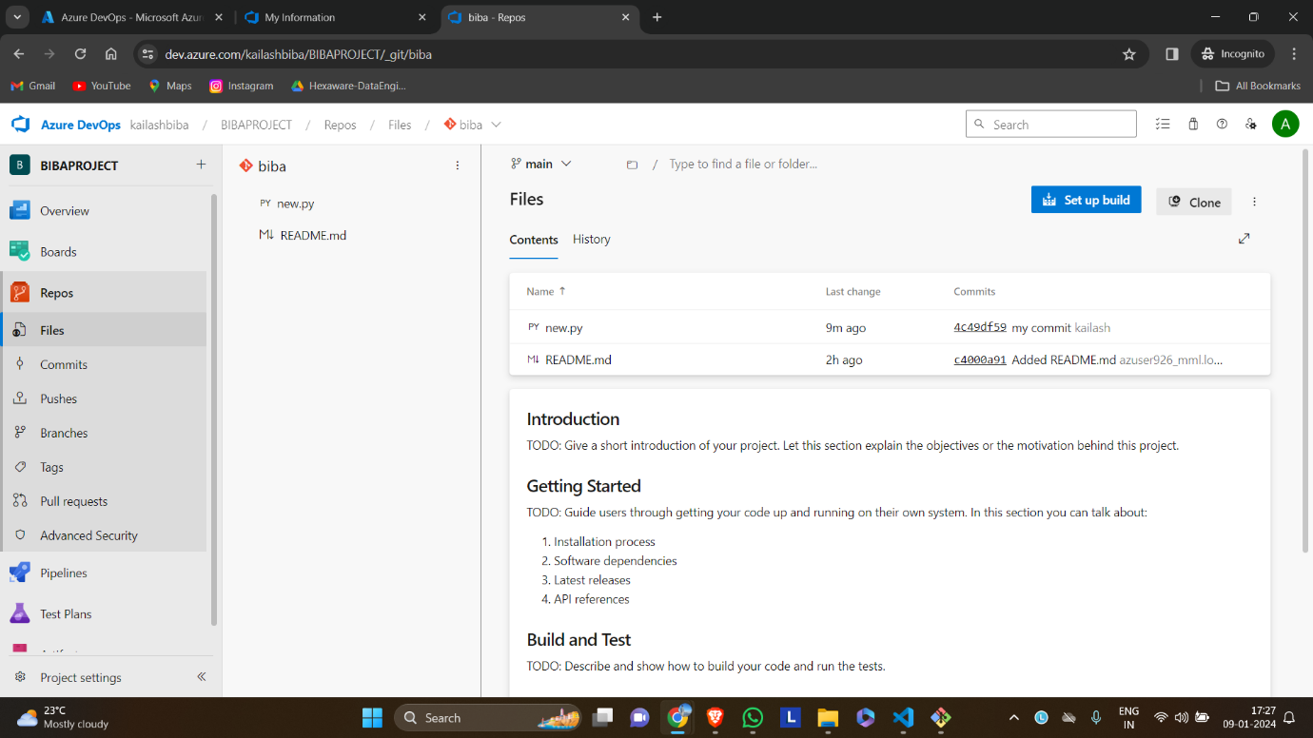

Deleting a azure repos

